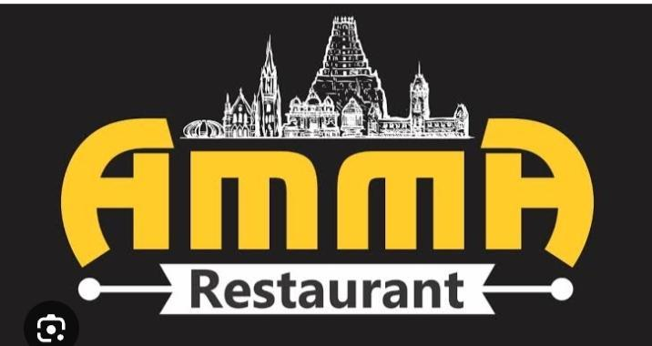

**This is our project work**

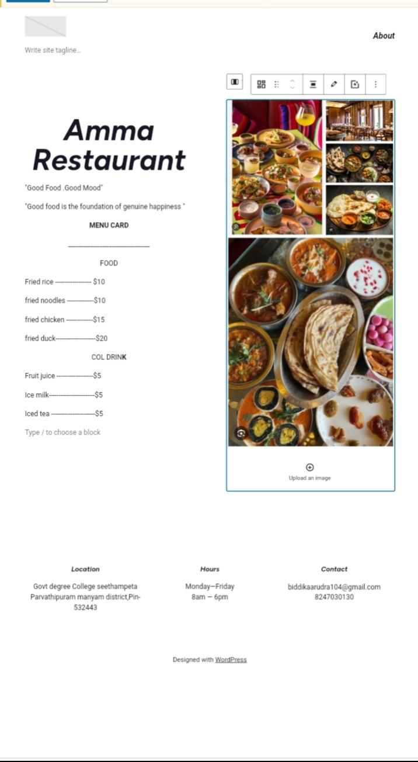

**INTRODUCTION**

**—---------------------**

**A restaurant is a business that prepares and servers food and drinks to customers.Meals are generally served and eaten in the premises.but many restaurants also offer take out and food delivery services.**

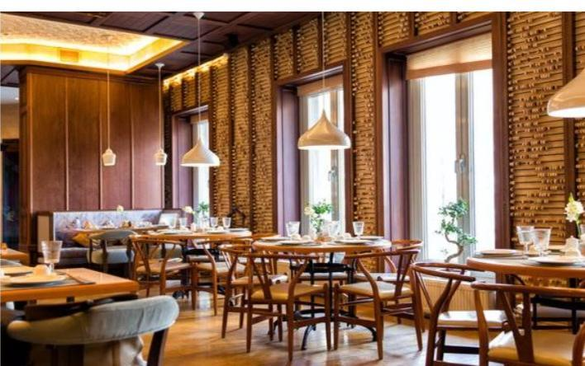

**The dining room of the restaurant in**

**Seethampeta**

**Restaurants vary greatly in appearance and offerings.including a wide variety of cuisines and services models ranging from inexpensive fast food restaurants and cafeterias to mid priced family restaurants.to high priced luxury establishments.**

**Restaurant Manager**

**—---------------------------**

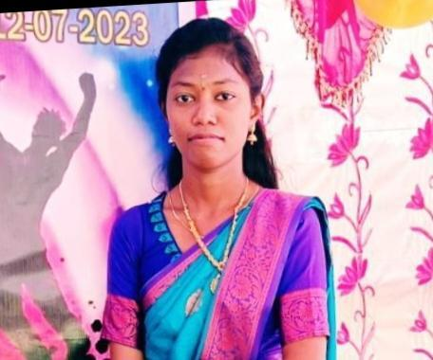

**Mis.Arudra**

**Shift manager**

**—----------------------**

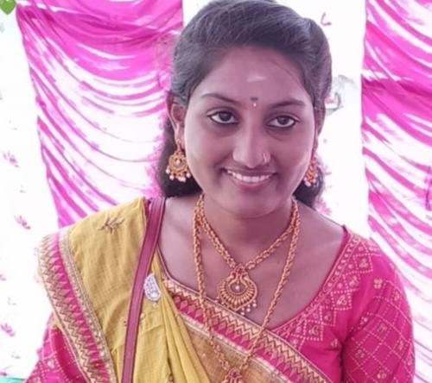

**Mis.Srilaxmi**

**Restaurant Genaral manager**

**—---------------------------------------**

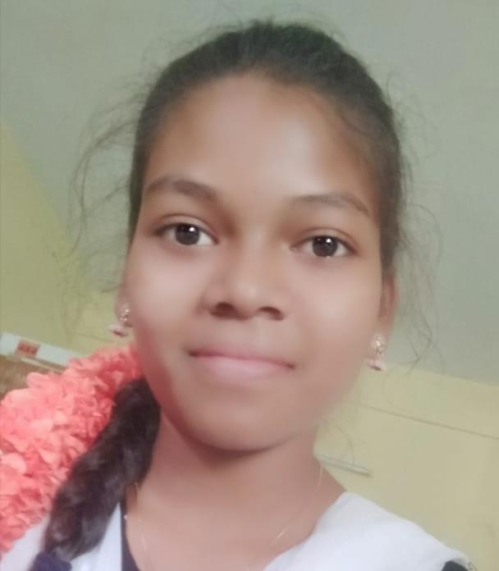

**Mis.Rajeswari**

**GAsst manager**

**—-------------------**

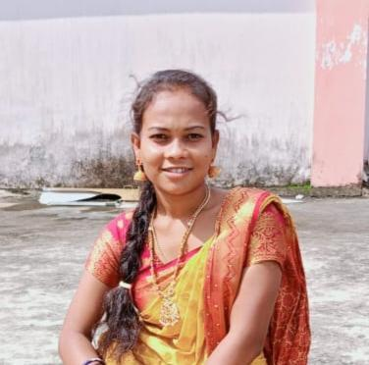

**Mis Divya**

**MENU CARD**

**—--------------------**

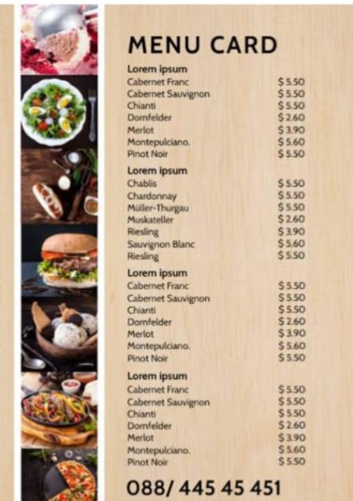

**Location**

**—-----------**

**Govt degree College seethampeta……**

**Contact**

**—---------**

**8247030130(biddika Arudra)**

**Web site link**

**—-------------------**

**ammarestaurant46.wordpress.com**

**https://ammarestaurant7.wordpress.com**

